# Unit 9 - Requirements Table

Lucas Miltiadou



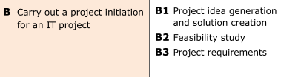

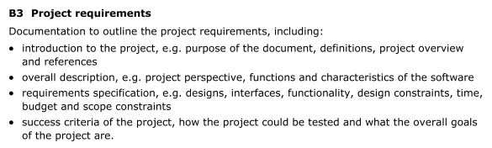

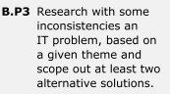

|  |  |  |  |  |
| --- | --- | --- | --- | --- |
| **Req Ref Num** | **Extract from the brief (Verbatim)** | **P3 Functional / Non Functional Requirement** | **P3 Success Criteria** | **Competitor Research / What Makes it Effective** |
| **1** | Home Page | Functional | This is important to show the users of the website. | It features several different areas of work and commitment that the organization has, as well as the opportunity to navigate several other areas or the website |
| **2** | About Us page | Functional | The about page will display important information about the society and will try to inform the users about who they are and what they do. | It will list each officer in the society and explain what their job role is and why they would do it. |
| **3** | Membership Page | Functional | The membership program will give users detailed information about each membership which includes the price. There will be three tiers of membership with them being personal, corporate and student. | The membership page is designed to be effective to its target audience, so that they will opt in to be a member. |
| **6** | Contact Page | Functional | Finally, the contacts page will contain the email address of the society if a user wants to contact them and will also have a form that users can fill out if they have any enquiries with the society. This form will have validation | The contact page will need to have the relevant information in order for the page to be effective, it would need to work as well. |
| **7** | Mobile Version of the Website | Functional | There will be a functional version of the website on mobile so that will display and use every feature that is available on the standard desktop version of the website. | An effective mobile optimised page will allow for users on other devices that are not PCs or laptops able to view the website. |
| **9** | Live Twitter Feed | Functional | There will be a feed of the @WorcesterCivic twitter page displaying in of the posts. | A live Twitter feed on the website will allow for the user to get up-to-date information on WCS, whereas the information on the website will have to be updated and then the site will need to be published. |
| **10** | Have external links to other websites | Functional | There will be a section of the website that will contain external links to another website. | Having external links to other websites will be effective because it allows for users to find out more information about things that are happening for WCS and other organisations as well as places that events may be happening at. |
| **12** | Display the logo and slogan of the society | Functional | The logo of the society will be displayed on each page by putting it on a master page. | The display of a logo will be effective because it allows for the user to recognise the organisation much quicker and easier than reading the name. |
| **13** | Accessibility for users who might struggle to use the website. |  | There will be a way for people with disabilities such as blindness to access and use the website. | Accessibility for people with disabilities will be effective since it will allow for an extended range of audience. Having features that cater for disabled users lets them navigate and view the website with ease. |
| **14** | Usability for intended target audience | Non-functional | It will be accessible and extremely uses able for my target audience which will be thoroughly researched. Things like their skill level and their familiarity of navigating websites will dictate how I will design the navigation. Also things like the font, text size and text colour. | This will be effective because it will mean that the target audience will have a website designed for them so that they will be able to access it with ease. |

**Purpose of Website**

The purpose of this website is to provide information about Worcester Civic Society

**Primary target audience**

* Someone who is looking for a group to join within Worcester
* Between 60-80, most likely male however could be female.
* What kind of technology would they use to access the website:
  + Computer or mobile device.
* How technically competent are they?
  + They may not be very tech confident due to their age and lack of experience. The site will need to be simple to help provide all of the information they are looking for.

**Secondary target audience**

* Teenagers who are interested or young adults.